PRIMARY CARE SOAP NOTE
Student:
Date:
Professor
PATIENT INFORMATION:
NAME: Peter AGE: 16
SEX: Male
SUBJECTIVE
HPI: Peter, a 16-year old adolescent walks into the entrance of the clinic feeling a lot of pain in the lower abdomen.to some extend, peter was unable to move by himself so he leaned on the clinic wall. Then the pain was so intense, he was very weak on the joints. Peter says the abdominal pains started at night while carrying out some activities in the house. He is not sure about the cause of the pain since during the night he was very fine. He took his normal meals during the day and night and he did not expect anything to bring distractions.it was the previous night he had some pain in his joints but the pain persisted for a while. After taking some painkillers, the pain was not intense as before. Peter does not show any other severe symptoms at the moment.
ALLERGIES:
The patient says he is allergic to some medicines including aspirin, ibuprofen, and certain antibiotics. Other allergies include foods such as eggs and cow's milk.
CURRENT MEDICATIONS
There is no current medication peter is on.
PMHX: None
FAMH: The patient agrees one of his family members had suffered Rheumatoid arthritis.
SOCHX: The patient denies that he has not been smoking and drinking alcohol. He terms it as being illegal to do it.
REVIEW OF SYSTEMS:
CONSTITUTIONAL: Rheumatoid arthritis
HEENT:
HEAD: The patient had a Cervicogenic headache, a one-sided headache that got worse when he moved his neck and head.
EYES: The eyes were red and very painful. The patient complained of sensitivity to light and blurred vision.
EARS: The patient had problems with balance. He experienced fullness in his ears and some hissing.
NOSE: The patient had no problem with his nasal cavities.
THROAT: The patient experienced hoarseness while speaking; he had a dull ache in the back of the neck around the base of the skull.
RESPIRATORY: The evaluation of the patient’s respiratory system shown that the patient had a scary within the lung with a chronic dry cough.
CARDIOVASCULAR: The patient had no history of cardiovascular diseases.
GASTROINTESTINAL: The patient had an infection on the lower section of the digestive system according to the lab tests that were conducted.
GENITOURINARY: The physical examination of the patient showed that he had a swollen bladder and a lot of pain in the lower spine and pelvis.
MUSCULOSKELETAL: The patient had a limitation of motion.
NEUROLOGIC: The central nervous system of the patient was functionality had no abnormality.
OBJECTIVE:
CONSTITUTIONAL: The lower section of the abdomen was affected by an infection that’s the reason the patient could not washstand the pain. Several laboratory tests were conducted to determine the cause of the infection. E-rays were also taken to determine the cause of the infection.
SKIN: The skin did not show any abnormality
HEENT:
NECK: The physical examination of the neck did not reveal any abnormality
RESPIRATORY: Respiratory tests have shown that the patient was having normal respiratory activities.
CARDIOVASCULAR: The patient had no cardiovascular symptom
GASTROINTESTINAL: The gastrointestinal test revealed some abnormality in the lower section of the abdomen.
GENITOURINARY: After conducting some tests, the urinary bladder was found to be functionally normal.
PERIPHERAL VASCULAR: The patient had no potential risk of vascular infection.
MUSCULOSKELETAL: The patient's joints were functioning normally.
NEUROLOGIC: The test did not reveal any abnormality.
ASSESSMENT:
DIAGNOSIS: The patient had a lot of pain in the abdomen. A test on the lower section was shown palpation of the abdomen. The patient experienced some difficulty in movement. The patient had some stiffness, a swelling on the swelling and fatigue. Again the patient developed stomach cramps and inflammation.

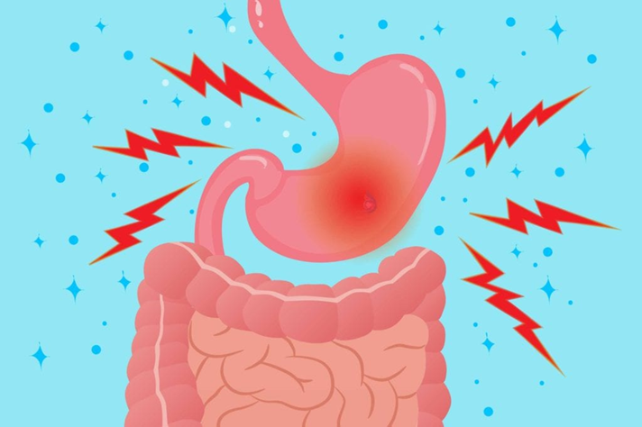
DIFFERENTIAL DIAGNOSIS: The differential diagnosis is administered after the symptoms of the infection were determined such as swelling on the section of the lower section. The diagnosis was done after the patient's condition could not improve. To help with diagnosis, a physical examination of the skin and any swelling can be done. The pain can be very painful as shown in the picture.

PLAN: Rheumatoid arthritis was treated in two ways, one of the ways includes control of the patient’s signs and symptoms, and secondly by maintaining the patient's quality of life and ability to function.
Non-Pharmacologic treatment: Non-pharmacologic treatment is the first step in treating this person with rheumatoid arthritis.it includes rest, doing exercise, doing physical and occupational therapies.
Pharmacologic treatment:
MEDICATIONS: Many medications can reduce swelling and inflammation to prevent or slow down the disease. The patient can be administered Disease-modifying anti-rheumatic drugs such as methotrexate.
FOLLOW-UPS/REFERRALS: The follow-up was scheduled after 2 weeks of treatment. In case of similar pain in different body parts, the patient should notify the doctor immediately.
RATIONALE: When this disease is diagnosed early, treatment can be possible. Poor patient compliance can fail the treatment. Prophylactic treatment should not give during the time of treating Rheumatoid arthritis.

